Sambhram Academy of Management Studies
School of Management
International Conference on Agricultural Value Chain and Marketing
March 30, 2023/ The Report

The current global context for agriculture is characterized by rapid change and increasing challenges. Several factors contribute to the changing context; many countries have slowly reformed agricultural policies. This has contributed to increased trade and a greater role for the private sector in agriculture vis-à-vis the State. This change in food retailing has led to greater involvement of the private sector in agriculture and a focus on developing and improving agriculture value chains (AVCs) in terms of quality, productivity, efficiency, and depth. With this backdrop, Sambhram Academy of Management Studies, School of Management, organised a One Day International Conference on “Agriculture Value Chain and Marketing” in its Campus.

Dr. G.J. Suresh, Assistant Professor, Department of Post-Harvest Technology, College of Horticulture (P.G. Centre) University of Horticultural Sciences, GKVK Campus, Bangalore was the Chief Guest and Ms. Asawari Amlekar, AGM, NABARD, Bangalore was the Guest of Honour. Shree B.N. Nagaraj, IPS, (Retired) CEO, Sambhram Group of Institutions and Prof K.C. Mishra Principal, Sambhram Academy of Management Studies were present as Special Guests at the inaugural function. Prof. K.C Mishra gave the welcome address and spoke on the theme of the conference. Sri B.N. Nagaraj, in his Presidential Address, called upon the need for having Agriculture Value Chain and Marketing to strengthen agriculture and also generate employment opportunities. Dr. G. J. Suresh in his key note address spoke about the importance of Agriculture and Horticulture and also on consumption of fruits and vegetables to have good health. He also spoke about the need to have start-ups in Agriculture with Government Support. The inaugural session ended with vote of thanks by Dr. Smitha. N.S.

The Panel Discussion on the topic “The Agricultural Value Chain: Challenges and Opportunities” was taken up by two speakers Dr. G. J. Suresh and CMA Dr. Gurudath. The former speaker initiated his presentation by the quotation “Agriculture is the mother of all the cultures in India” and plays a vital role in India’s economy, but agricultural land is fixed and it is shrinking because of demand for house, roads, industry, educational institutions etc. Agricultural scientists are having important role in increasing agricultural production and reducing the losses. The focus of his presentation was to highlight key areas for agricultural transformation. Supporting this he shared some more facts on Agriculture like: the agriculture industry in India has contributed INR 71,220 billion in 2021 which is expected to reach INR 142,280 billion by 2027 at a growth rate (CAGR) of 12.3% during 2022-2027.Agriculture’s significant role in India’s economy: 54.6% of the total workforce is engaged in agricultural and allied sector, it contributes 19% to GDP and ranks second worldwide in farm output through total agriculture commodities export: US$ 3.5 billion in 2020. Agriculture Production of India is huge focusing that the year 2023 has been declared by the United Nations as the International Year of the Millet as a result of India’s proposal which wants to position itself as a global hub for millets: millet production has increased from 3235.54 lakh tonnes to 79.38 lakh million tonnes. Value chain mapping should take place which is a process of identifying markets, conducting survey, interview, and research and quantify value addition at each stage. Some measures to double farmer’s income are:
1. Improvement in crop productivity
2. Improvement in livestock productivity
3. Resource use efficiency/saving in cost of production
4. Increase in cropping intensity
5. Diversification towards high value crops
6. Improvement in real prices received by farmers

Value chain was first popularized in a book published in 1985 by Michael Porter who used it to illustrate how companies could achieve what he called “competitive advantage” by adding value within their organization and focused that value chain is an integrated range on goods and services necessary for an agricultural product to move from the producer to the final consumer. He also explained the case study by sharing the photos, Samruddhi -A Value Chain Start-up, how one of his student with a Agri Start-Up has attained sales of 12 tons and turnover of 5.4 Lakh INR/month in wheat based Atta product for which his effort was praiseworthy from honourable people like India’s Finance Minister Ms. Nirmala Sitaraman, Karnataka Chief Minister Mr. Bommai and others Ministers Ms. Shailaja, Mr. B.C. Patil and few more. The agricultural supply-chain highlights are:

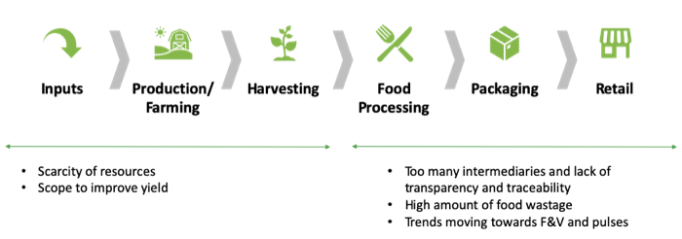
Opportunities in the Agriculture Value Chain:
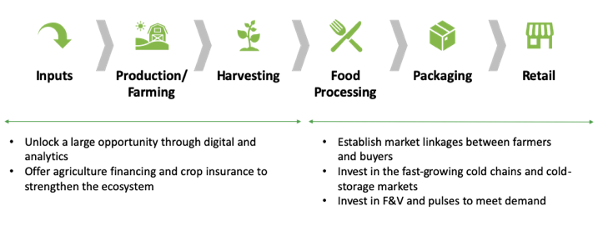
The role of Digital Ecosystem in Agriculture:
- The agri-tech stakeholder ecosystem is rapidly maturing
- There are 450 agri-tech start-ups in India and growing at a rate of 25% year on year
- Every nineth agri-tech start-up in the world is from India

There is huge opportunity to target all the sections of the agriculture value chain

1. Better access to inputs
2. Financing
3. Digital Agriculture
4. Improving the Supply chain
5. Farming as a service

Future road map for Agri-Startups:
- Supply chain
- Logistics
- Value Chain
- Value Addition
- Processing, Packaging and Storage infrastructure
- Efficient Marketing Channels
- Better access to Finance
- Cooperatives and Contract Farming
- FPOs
- Better policies for regulations and governance
- R&D

The second speaker CMA Dr. Gurudath discussed about pest control, soil fertility etc. which is a big task for farmers. Block Chain Management and Big Data help agriculture sector and vertical and green house farming have also taken greater importance in improving agriculture. Smart farming and consumer linking emphasized the need to educate farmers about the use and importance of smart farming as well as organic farming.

Prof Suhani Sharma invited the Guest of Honor Dr. G J Suresh to deliver Special Address on the occasion and to Chair the Session. Together to improve productivity and the value added from their activities in a well managed value chain, the value of the end-product is often greater than the sum of individual value additions. The economic performance of a developing country like India largely depends on the performance of its agriculture and allied sectors. This sector plays a significant role in rural livelihood, employment and national food security. It happens to be the largest source of livelihoods in India. Proportion of Indian population depending directly or indirectly on agriculture for employment opportunities is more than any other sector in India. It’s interesting how millets can help the world face the challenges confronting it. Millets have been an integral part of our diet for centuries. In addition to a plethora of health benefits, millets are also good for the environment with low water & input requirement. With the aim to create awareness and increase production &consumption of millets, United Nations, at the behest of the Government of India, declared 2023 the ‘International Year of Millet’.

Dr. Suresh deliberated on Agriculture value chain and suggested transformation in agriculture sector requires use of appropriate productivity enhancing inputs and technology to intensify specialization, diversification and value addition. Farmers need to arrange agronomic and business skills to make well-informed investment decisions for greater production and profitability. The current global context for agriculture is characterized by rapid change and increasing challenges. Several factors contribute to the changing context. Many countries have slowly reformed agricultural policies. This has contributed to increased trade and a greater role for the private sector in agriculture vis-à-vis the state. Increasing population, income, and urbanization, which are changing diets along with the use of food crops for biofuels, have contributed to increased food prices. As consumer demands related to safety, quality, convenience, and organic and processed foods increase, the gap between farm and consumer prices is widening. Supermarkets are emerging as a major stakeholder in food retailing. Collectively, these changes contribute to a paradigm shift in the way food is produced, processed, and sold. In particular, the increased demand for safe, higher value and differentiated agricultural products has created opportunities for farmers and agribusiness entrepreneurs to transform commodities into products that are demanded by consumers. This change in food retailing has led to greater involvement of the private sector in agriculture and a focus on developing and improving agriculture value chains (AVCs) in terms of quality, productivity, efficiency, and depth. Value chains are organized linkages between groups of producers, traders, processors, and service providers (including nongovernment organizations) that join.

After the close of the panel discussion, research papers were presented by the participants from various Colleges and Universities across the globe. Paper presentation track was coordinated by Prof Suhani Sharma; 20 participants across the globe presented their research papers on various topics like Agriculture and Rural Development in Karnataka through MAHATMA GANDHI NATIONAL RURAL EMPLOYMENT GUARANTEE ACT, Indian Agriculture and its threat and challenges, agriculture finance, insurance and risk management in India, prospects of value chain management and its significance in agriculture.
Breakout Discussions
Key points highlighted by the participants
1. As agriculture growth and development has direct bearing on reducing poverty. Essentially entrepreneurial actions associated with agriculture generate innovative practical solution for aid in increasing farm income, employment and rural prosperity.
2. The government should implement some policies to protect young entrepreneurs from the risk of Agri-tech business losses. Meanwhile government needs to provide them with a conducive environment if we need the ecosystem to flourish and reap the benefits.
3. Agri-tech advancements are extremely important for the Indian economy as well as for countries dependent on India’s exports.
4. Government should focus onpolicies and educational programs for efficient utilization of economic incentives and use of modern mechanization and sustainable technologies for agriculture. Such efforts will gainfully ensure stable supply of nutritionally adequate food.
5. Further the right mix of managerial skills and entrepreneurial expertise imparted through various institutions and interventions would facilitate accomplishment of the growing needs of Agri business
6. A value chain approach in agriculture development helps identify weak points in the chain and actions to add more value but it is very essential to find out gap in the chain and cover the gap with the growth expectation of farm and farmers.
After the paper presentations, Dr. G J Suresh gave concluding remarks and also suggested some key points to the participants to fill the research gap. Prof Arpita Sastri proposed vote of thanks to all the dignitaries and participants on behalf of Sambhram Academy of Management Studies. Prof K C Mishra in his closing remark remained grateful to all the speakers of the day and desired the same kind of cooperation in future and the program ended with a strong positive note.
Conference Declaration
Indian agriculture supports income and livelihood opportunities to majority of the population. It has undergone rapid transformations from subsistence farming to commercial agriculture. Despite of achieving significant transformations, there are many lacunae existing in the present systems which are unable to fetch a good price for the producer. Value addition and efficient marketing may enable farming more profitable. A holistic approach that connects the three (economic, environmental, social) aspects of Agriculture Value Chain (AVC) needs to be adopted to refocus on agricultural growth.

