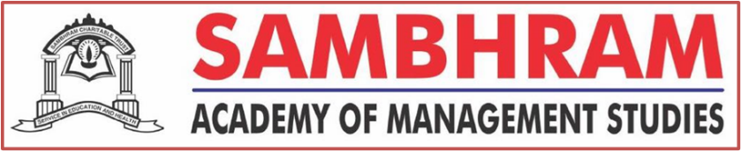
Guest Lecture-cum-Seminar
Dr. B K Gupta
(Motivational Guru, Social Scientist, Entrepreneur)
Topic: “Mistakes to Miracle”
February 17, 2023
Sambhram Academy of Management Studies welcomed a Renaissance Personality Dr. Brij Kishore Gupta to stimulate the MBA and M Com First Semester Students on the path of growth and development. Dr. Gupta is a renowned Motivational Speaker and Social Scientist having broader perspective and way of thinking towards life. The Topic of the talk “Mistakes to Miracle” was quite fascinating and enticing”. The eminent speaker kindled his talk by probing a question to the students, asking them about the role of past and present in our life. We are not able to fly high because somewhere past mistakes are stumbling blocks on the path of success. We all make mistakes, have struggles, and even regret actions of the past. But you are not your mistakes, you are not your struggles, and you are here to shape your day and future. Making mistakes is an inevitable part of the human experience but we all try to learn and grow from those mistakes that matters. Dr. Gupta showed many videos to the students and asked them to interpret those videos based on their understanding. All the videos were based on the attitude of achievers, how without thinking about criticism, they have achieved the pinnacle of success. He used one very suitable acronym LKK (LOG KYA KAHENGE) which really make sense in terms of a very important component of success.
The speaker was able to create a thunder in young minds, motivated them to rethink and re-energize with his motivating poems, quotes and stories. Students were really able to connect with him and everyone felt so elated. The session ended with positive note and the speaker wished the students for their future endeavours.

